HealthConnect Clinic — Appointment No-Show Prediction

Week 7: Testing, Refinement & End-to-End Validation
Track: Data Analytics
Project: HealthConnect Clinic
Objective: Reduce missed appointments and improve patient experience

Project Overview
HealthConnect Clinic is a healthcare data analytics project focused on understanding and reducing missed medical appointments (no-shows).
The project analyzes appointment data to identify factors associated with missed appointments and evaluates Machine Learning models capable of identifying patients who may be at higher risk of not attending their appointments.
The Week 7 phase focuses on testing, refinement, model evaluation, visualization, and end-to-end validation of the analytical workflow.

2.Objectives
The main objectives of this project are to:
- Measure the overall rate of missed appointments.
- Analyze the relationship between SMS reminders and appointment attendance.
- Identify patterns according to age groups.
- Analyze no-show patterns by day of the week.
- Investigate the relationship between appointment lead time and attendance.
- Compare different Machine Learning approaches.
- Optimize the classification threshold.
- Evaluate model performance using appropriate metrics.
- Identify the most important predictive features.
- Transform analytical results into information that can support healthcare decision-making.

2.Analytical Workflow
The project follows an end-to-end Data Analytics workflow:
Raw Appointment Data
↓
Data Loading
↓
Data Preparation & Cleaning
↓
Exploratory Data Analysis
↓
Statistical Analysis
↓
Machine Learning
↓
Model Evaluation
↓
Threshold Optimization
↓
Feature Importance
↓
Visualization
↓
Operational Insights

3.Key Performance Indicators
The analysis validates several important healthcare appointment KPIs:

1. Global No-Show Rate
Measures the overall proportion of appointments that were missed.

2. SMS Reminder Association
Compares appointment attendance between patients who received SMS reminders and those who did not.
Important: the analysis describes an association between SMS reminders and attendance. It does not establish a causal relationship.

3. No-Show by Weekday

Identifies differences in missed appointments across days of the week.
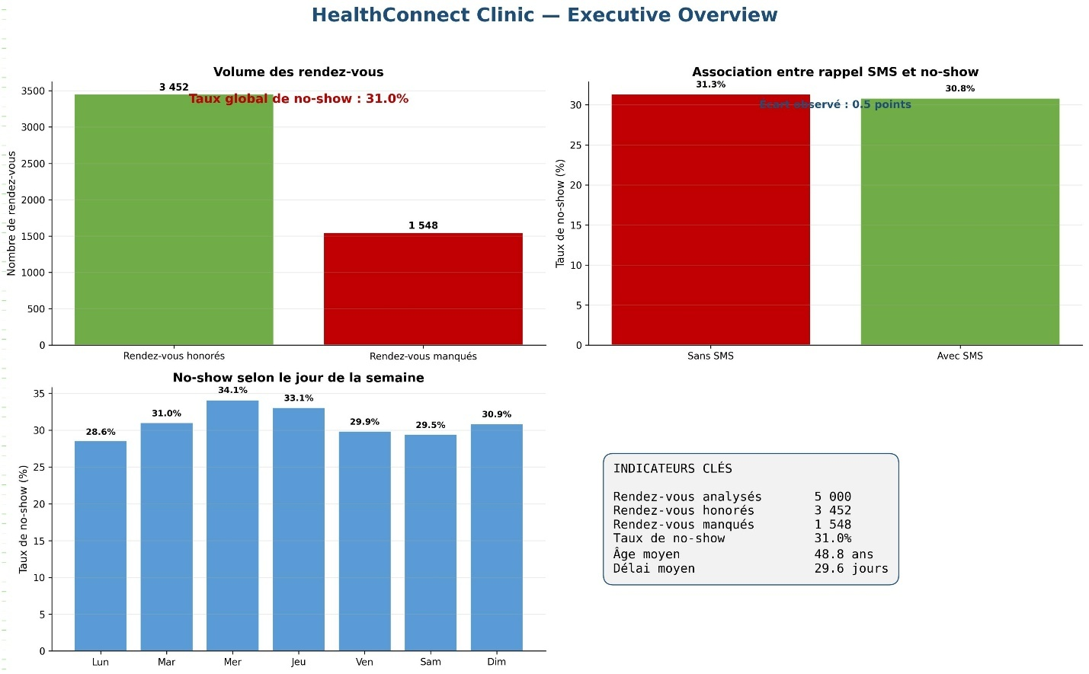

4. No-Show by Age Group
Analyzes appointment attendance patterns across different age categories.

5. Lead Time
Examines the time interval between appointment scheduling and the appointment date.

4. Lead Time and No-Show Relationship
A correlation/trend analysis is used to investigate whether longer waiting periods are associated with missed appointments.
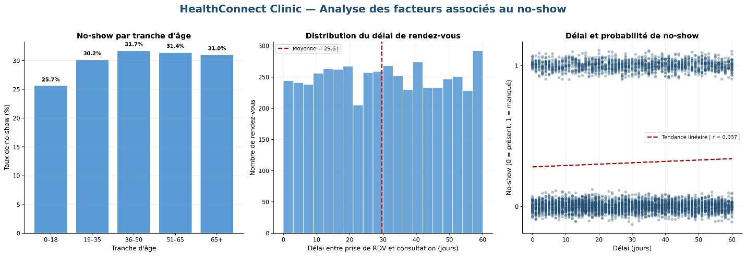

Machine Learning
Two approaches are evaluated:

Logistic Regression
Used as a baseline classification model.

Random Forest
Evaluated as a candidate model for capturing potentially non-linear relationships between appointment characteristics and no-show behavior.
The Random Forest implementation uses class balancing to address the classification problem.

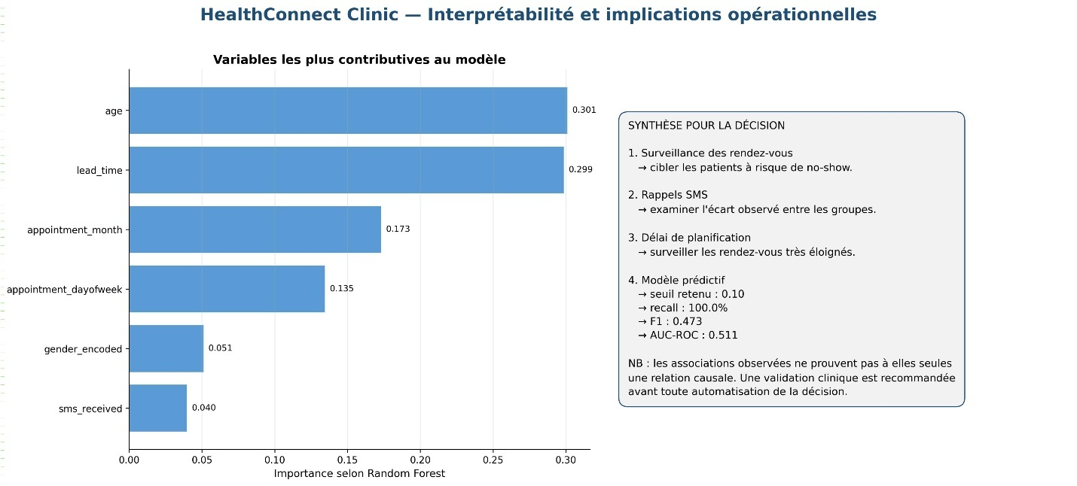
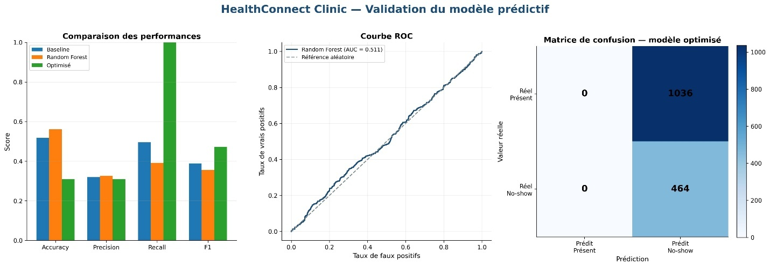

Model Evaluation
The models are evaluated using:
- Accuracy
- Precision
- Recall
- F1-score
- AUC-ROC
- Confusion Matrix
- ROC Curve
The classification threshold is also optimized to improve the balance between precision and recall according to the project's objective.

6.Model Interpretability
Feature importance is analyzed to identify which variables contribute most to the Random Forest predictions.
This step is important because a predictive model should not only generate predictions but also provide information that can help healthcare teams understand the factors associated with appointment attendance.

7. Visualizations
The project produces four professional analytical dashboards.

01 — Executive Overview
Provides a high-level view of:
- Appointment volume
- Global no-show rate
- SMS-related attendance patterns
- No-show by weekday
- Main KPIs

02 — Behavioral Analysis
Explores:
- No-show by age group
- Lead-time distribution
- Lead time versus no-show
- Correlation/trend analysis

03 — Model Performance
Presents:
- Model comparison
- Classification metrics
- ROC curve
- AUC
- Confusion matrix

04 — Interpretability & Action
Highlights:
- Feature importance
- Main analytical findings
- Potential operational implications

Technologies Used

Programming & Data Analysis
- Python
- Pandas
- NumPy

Data Visualization
- Matplotlib
- Seaborn

Statistics
- SciPy

Machine Learning
- Scikit-learn

Data Sources & Files
- CSV
- Excel-compatible tools

📁 Project Structure
HealthConnect-Clinic/
│
├── HealthConnect_Week7_Professional_DISPLAY.py
│
├── HealthConnect_Appointment_Data.csv
│
├── HealthConnect_Week7_Outputs/
│ ├── 01_HealthConnect_Executive_Overview.png
│ ├── 02_HealthConnect_Behavioral_Analysis.png
│ ├── 03_HealthConnect_Model_Performance.png
│ └── 04_HealthConnect_Interpretability_Action.png
│
└── README.md

Key Learning Outcomes
This project strengthened practical skills in:
- Healthcare Data Analytics
- Exploratory Data Analysis
- Data Cleaning and Preparation
- Statistical Analysis
- Classification
- Machine Learning Model Evaluation
- Threshold Optimization
- Feature Importance
- Data Visualization
- Healthcare Decision Support
- End-to-End Analytical Workflow

Healthcare Impact
Missed appointments can affect patient follow-up, healthcare resource utilization, and continuity of care.
By combining Data Analytics and Machine Learning, HealthConnect Clinic demonstrates how appointment data can be transformed into actionable information for healthcare teams.
The analytical workflow can potentially support strategies such as:
- identifying patients requiring additional attention;
- improving appointment reminder strategies;
- understanding attendance patterns;
- supporting operational planning;
- improving patient experience.
The model should be considered a decision-support tool, not a replacement for clinical or administrative judgment.

📚 Project Context
This project was developed as part of Week 7 — Testing, Refinement & End-to-End Validation within the Data Analytics track.
The focus of this phase was not only to build a model, but to validate the complete analytical pipeline:
Data → Analysis → Model → Evaluation → Interpretation → Decision Support

👨‍💻 Author
Dr. Triphène Koleka Mangietimona
Medical Doctor | Public Health Professional | Health Data Science Practitioner
Interested in:
- Health Data Science
- Digital Health
- Healthcare Analytics
- Machine Learning
- Health Systems Transformation
- Data-Driven Decision Making

🙏 Acknowledgment
This project was developed during my Data Science learning journey with AnalystLab Africa, providing an opportunity to strengthen practical skills in Data Analytics, Machine Learning and healthcare data applications.

📌 Keywords
Python Data Analytics Data Science Machine Learning Healthcare Analytics Health Data No-Show Prediction Logistic Regression Random Forest Scikit-Learn Pandas Matplotlib Seaborn Digital Health

